Instructions for Authors

About the Journal

Imagining SoTL: Selections from the Banff Symposium (IS) stems from the annual Symposium for Scholarship of Teaching and Learning (SoTL), hosted by Mount Royal University’s Mokakiiks Centre for SoTL.
The Mokakiiks Centre is located in Treaty 7 territory, the hereditary homelands of the Niitsitapi (the Blackfoot Confederacy), Îyârhe Nakoda, and Tsuut'ina Nations. When asked to translate the previous name of the Institute for SoTL, Blackfoot elder Leo Fox gave the word ksimstaani, which means ‘imagining.’ We name the publication after this inspiring way of thinking about SoTL as possibility and potential for transformation.
Imagining SoTL accepts the following English language submissions: research articles, reflective essays, calls for collaboration, reports on SoTL in practice, and other scholarly works that investigate teaching and learning in higher education. Some issues also include invited essays and creative responses. IS aims for high quality and values methodological richness and variety from a diversity of perspectives.
Open Access Policy
Imagining SoTL is an open access publication. There are no article processing charges for publishing in IS. We believe that open access is a public good as it promotes sharing of knowledge. Such access is associated with increased readership and increased citation of an author's work.
Peer Review

All papers submitted to IS undergo an anonymous peer review process prior to publication. Invited pieces and creative submissions are peer-reviewed by the editorial board.

Preparing Your Article

Word Limit

Research articles should be no more than 6000 words (not including the abstract and references). Reflective essays should be maximum 4000 words, while creative responses will be maximum 1500. Special calls may have specific word limits.

Anonymization of Articles
The article abstract and metadata should be anonymized at the point of submission.

Third-party Material
Following acceptance, authors are responsible for obtaining permission to use any third-party material included in their articles.

Ethics Clearance
A statement in the article should indicate that ethics clearance was granted, where required.

Style Guidelines

The following contains an overview of guidelines to follow when submitting your paper to Imagining SoTL. If your article is accepted for publication, the manuscript will be further formatted. Given that we are also open to alternatives to traditional research articles, you may submit using an alternative format if it is called for by your topic, and is consistently implemented. You should explain your rationale in the cover letter. Decisions about alternate formats will be made on a case by case basis by the editorial team.

Formatting

Articles should be formatted in Times New Roman, 12-point font. They should be double-spaced with 2.5 cm margins.

Please indent paragraphs 1.27 cm, using the paragraph function in Word, rather than the “tab” key.

Headings should follow APA Style:

Level | Format
1 | Centred, Bold, Title Case Heading  Text begins as a new paragraph.
2 | Flush Left, Bold, Title Case Heading  Text begins as a new paragraph.
3 | Flush Left, Bold Italic, Title Case Heading  Text begins as a new paragraph.
4 | Indented, Bold, Title Case Heading, Ending With a Period. Text begins on the same line and continues as a regular paragraph.
5 | Indented, Bold Italic, Title Case Heading, Ending With a Period. Text begins on the same line and continues as a regular paragraph.

From the Publication Manual of the American Psychological Association (7th edition), p. 48.

Abstract and Keywords

Your article should include an abstract of no more than 150 words and a list of 3-5 keywords.

Spelling and Expression

Imagining SoTL uses the strange hybrid known as Canadian spelling, which blends British and American spelling. Please follow these examples:

- Use British spelling for words ending in “our” (e.g., colour) and “re” (e.g. centre).
- Use American spelling for words ending in “ize” (e.g. legalize).
- Use American spelling for “practice” (i.e., both the verb and the noun should end in “ce”) and “defense”
- If including a proper noun, use the original spelling.

Use gender-neutral, non-discriminatory language.

Numbers and Dates

Spell out numbers less than 10 unless they are used in the same sentence with larger numerals or unless the number refers to a section, page number, currency, time, measure, weight, or percentage.

Always use the % sign with numerals (67%; not 67 percent)

If a numeral appears at the beginning of a sentence, spell it out.

Example: Thirty-two of the students mentioned that they enjoyed collaborating with other students on the project.

Write dates as January 31, 2021, in the nineteenth century, in the 1990s.

Acronyms and Abbreviations

If using an acronym in your article, spell out the full name the first time you mention it, followed by the acronym in parentheses. Then use the acronym for all subsequent mentions.

Example: World Health Organization (WHO)

Do not use periods for abbreviations

Example: US, UK, BC, etc.

Quotations

Use double quotation marks for direct quotations and single quotation marks for quotations within quotations.

Any quotation of 40 words or more should be treated as a block quotation. Do not use quotation marks for block quotations, but rather indent them 1.27 cm.

If omitting words from the middle of a quotation, use an ellipsis to replace the omitted words. Do not place square brackets around the ellipsis or use an ellipsis for words omitted at the beginning or end of a quotation.

Use square brackets to indicate any alterations or additions made to a quotation. Use [sic] to indicate an obvious error in quoted material. Place [sic] immediately after the error.

Tables and Figures

Tables and figures should appear as close as possible to the text to which they relate.

When referring to a table or figure, use its number, rather than referring to “the table below” or “the figure on page 5.”

Example: Figure 1 demonstrates the difference in student response times to these various question types.

The table or figure number should appear in bold, followed by the title, on the next line, in italics (title case). Any notes should appear below the table or figure.

Table 1
Examination Performance Is Unaffected by SRS Question Type Used for Formative Assessment

Calculation  Category | Term | Correct | Incorrect | Total | % correct
Control | 1 – NRQ | 519 | 172 | 691 | 75.1%
 | 2 – NRQ | 632 | 216 | 848 | 74.5%
Chemistry | 1 – MCQ | 525 | 290 | 815 | 64.4%
 | 2 – NRQ | 631 | 360 | 991 | 63.7%
Microbiology | 1 – NRQ | 240 | 224 | 464 | 51.7%
 | 2 – MCQ | 300 | 266 | 566 | 53.0%

Figure 1
Paired Questions and Student Response Times
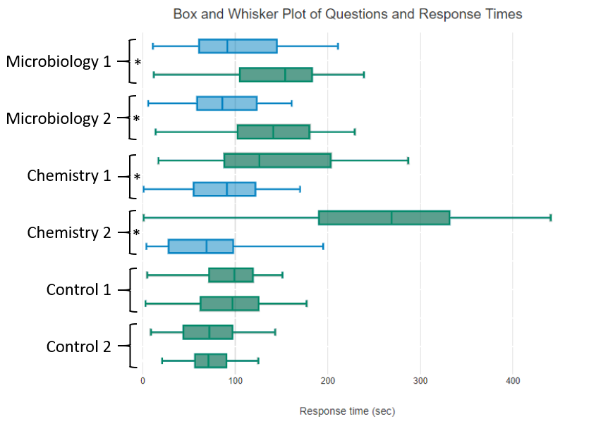
Note. Box and whisker plots show the mean response times and quartiles of student responses for six pairs of questions. Multiple choice questions (MCQ) are shown in blue and numerical response questions (NRQ) in green. In each pair the Term 1 cohort is on the top and Term 2 cohort is on the bottom. Paired sets shown with an asterisk (*) showed statistically significant variance in response times (P<0.001) by ANOVA analysis. Control question variances were not significant (P>0.05).

References

Imagining SoTL uses APA Style (7th edition). Please follow this format for all in-text citations, notes, and your references list.

Your list of references should be called “References,” and it should only include works cited in your paper. The references list should be alphabetized, double-spaced, and formatted using a hanging indent of 1.27 cm.

Here are sample references for some of the typical reference types. For further examples, please see Chapter 10 of the Publication Manual of the American Psychological Association (7th edition) or the following link:

https://apastyle.apa.org/style-grammar-guidelines/references/examples

Book

Andrew, S. (2017). Searching for an autoethnographic ethic. Routledge.

Chapter in a book

Poole, G., & Simmons, N. (2013). The contributions of the scholarship of teaching and learning to quality enhancement in Canada. In G. Gordon & R. Land (Eds.), Enhancing quality in higher education: International perspectives (pp. 118–128). Routledge.

Journal article

Healey, M., Flint, A., & Harrington, K. (2016). Students as partners: Reflections on a conceptual model. Teaching & Learning Inquiry, 4(2), 1–13. https://doi.org/10.20343/ teachlearninqu.4.2.3

Website

Monks, J., & Schmidt, R. (2010). The impact of class size and number of students on outcomes in higher education. Cornell Higher Education Research Institute, Cornell University. https://digitalcommons.ilr.cornell.edu/workingpapers/114/

